RADIANT PHARMACEUTICALS LIMITED

ICT Wing

(Daily Report)
INTERN PROFILE | DETAILS
Intern Name | Ibrahim Hasan
Student ID | 2110316
University | Independent University, Bangladesh
Department | Management Information System (MIS)
Supervisor | Ayan Chowdhury (Sr. Officer, ICT)

Daily Progress Report
Day # | Date #
Day 1 | June 9, 2026

Task Assigned:
Set up the Windows Subsystem for Linux (WSL 2) and Ubuntu Linux distribution on the Windows work PC, troubleshoot virtualization/installation errors, and test the Linux environment.

Learning Outcome:

During this task, I achieved the following learning outcomes:
• WSL 2 Architecture & Requirements: Learned that WSL 2 runs a real Linux kernel inside a lightweight utility VM, which offers full system call compatibility and significantly faster file system performance compared to WSL 1. Realized that WSL 2 requires hardware-level virtualization (Intel VT-x or AMD SVM) enabled in BIOS/UEFI, as well as the Windows features 'Windows Subsystem for Linux' and 'Virtual Machine Platform'.
• WSL Installation & Configuration: Practiced enabling system features using DISM commands in PowerShell and installing the Ubuntu distribution. Learned to initialize the Ubuntu distribution, set up a Unix user account, and run package updates/upgrades using 'sudo apt update && sudo apt upgrade'.
• Linux Command Line & Execution: Tested Python script execution inside the Ubuntu shell to verify package management and interpreter functionality, and checked kernel configuration details.
Screenshots of Installation and Environment Setup:
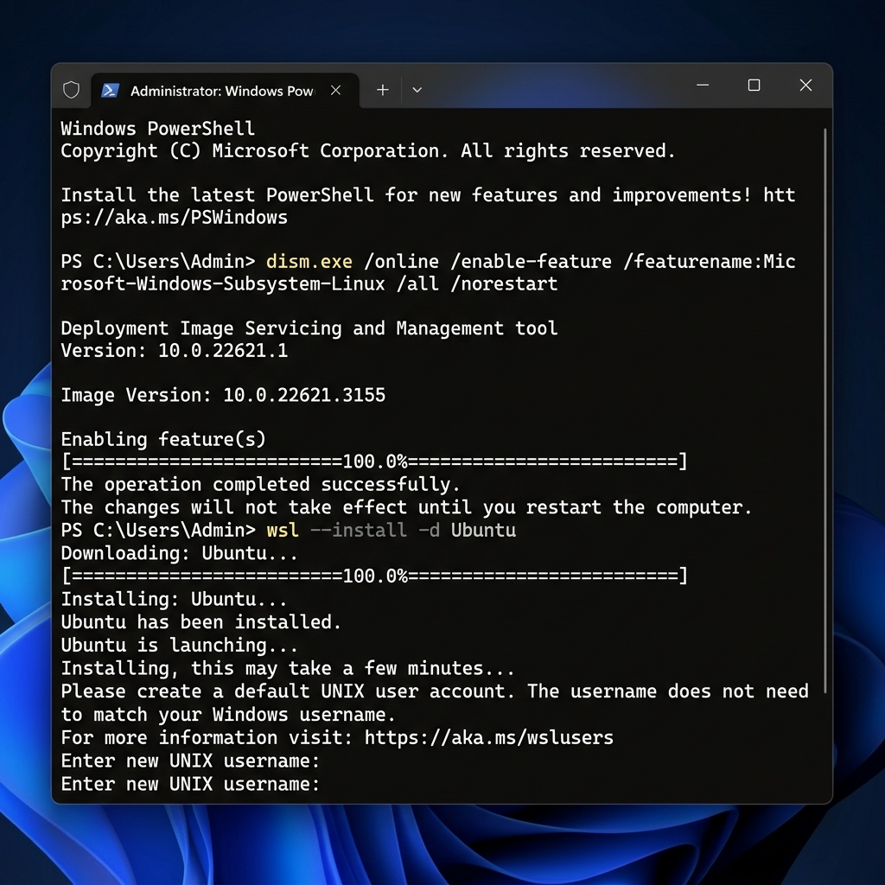
Figure 1: Enabling WSL and Virtual Machine Platform via PowerShell.
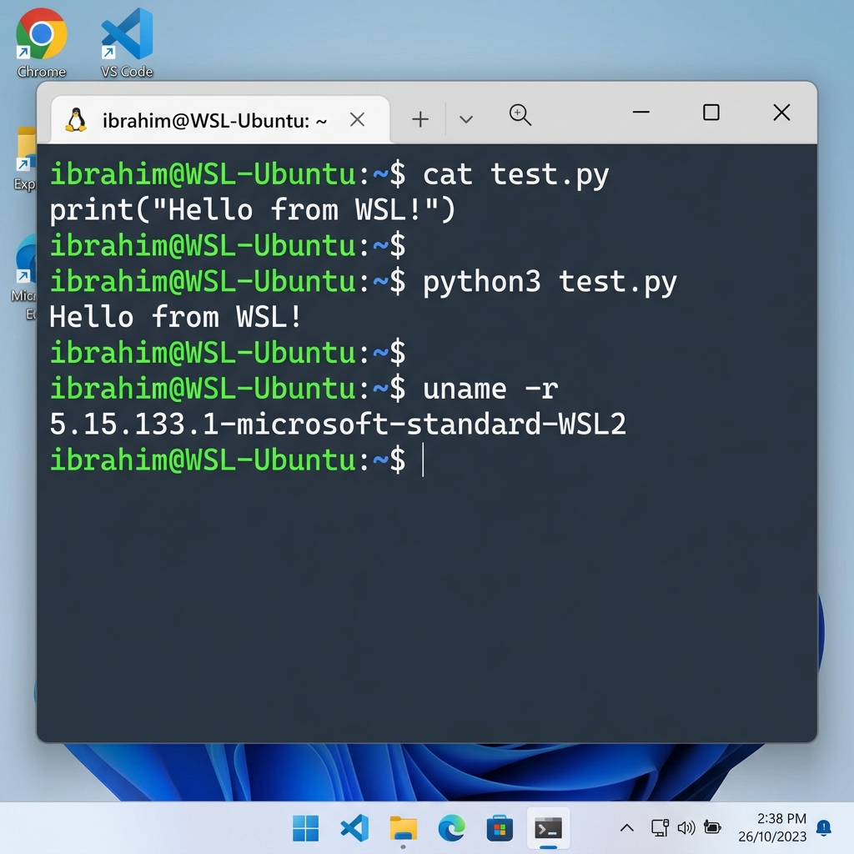
Figure 2: Verifying Python environment and testing code execution inside Ubuntu distro.
Work Completed:
• Configured BIOS settings to enable Intel Virtualization Technology (VT-x).
• Enabled the 'Windows Subsystem for Linux' and 'Virtual Machine Platform' optional Windows features via PowerShell using DISM commands.
• Downloaded and installed the Ubuntu distribution for WSL 2.
• Set up the default Linux user account and updated the package list and upgraded installed packages using 'sudo apt update && sudo apt upgrade'.
• Created and executed a test Python script ('test.py') in Ubuntu to verify python3 runtime functionality.

Problems Faced:
• Encountered launch errors for WSL 2 and the Ubuntu distribution. The command 'wsl --install' failed to initialize because CPU virtualization was disabled in BIOS/UEFI.
• The system prompted an error: 'Please enable the Virtual Machine Platform Windows feature and ensure virtualization is enabled in the BIOS.'

Solution Attempted:
• Rebooted the work PC, entered the BIOS setup utility, located CPU Configuration settings, and enabled 'Intel Virtualization Technology' (Intel VT-x).
• Opened PowerShell as Administrator and explicitly enabled the 'Virtual Machine Platform' Windows feature using:
dism.exe /online /enable-feature /featurename:VirtualMachinePlatform /all /norestart
• Rebooted the PC to apply the Windows feature updates, after which WSL 2 and Ubuntu initialized and launched successfully.

